**2017**

1. The human ear can detect continuous sounds in the frequency range from 20 Hz to 20000 Hz. Assuming that the speed of sound in air is 330 m/s for all frequencies, calculate the wavelengths corresponding to the given extreme frequencies of the audible range. [2 marks]
2. An enemy plane is at a distance of 300 km from radar. In how much time the radar will be able to detect the plane? Take velocity of radio waves as 3x108 m/s [2 marks]
3. How is the frequency of a stretched string related to
   1. Its length
   2. Its tension [2 marks]
4. Name the factor that determines
   1. Loudness of the sound heard
   2. Quality of the note
   3. Pitch of the note [3 marks]
5. (i) What are damped vibrations

(ii) Give an example of damped vibration

(iii) name the phenomenon that cause a loud sound when the stem of a vibrating tuning fork is kept pressed on the surface of a table [3 marks]

1. A wire of length 80 cm has a frequency of 256 Hz. Calculate the length of a similar wire under similar tension, which will have frequency of 1024 Hz. [2 marks]
2. A certain sound has a frequency of 256 Hz and wavelength of 1.3 m.
   1. Calculate the speed with which this sound travels
   2. What difference would be felt by a listener between the above sound and another sound travelling at the same speed, but of wavelength of 2.6 m [2 marks]

**2016**

1. The ratio of amplitude of two waves is 3:4 what is the ratio of their **[2 marks]**
   1. Loudness
   2. Frequencies
2. State two ways by which the frequency of transverse vibrations of a stretched string can be increased **[2 marks]**
3. What is meant by noise pollution? Name one source of sound causing noise pollution [**2 marks**]
4. (a) Name the phenomenon involved in tuning a radio set to a particular station

(b) Define the phenomenon named by you in the above question

(c) What do you understand by loudness of sound?

1. (d) In which units is the loudness of sound measured? **[4 marks]**

**2015**

1. (a) Draw a graph between displacement and the time for a body executing free vibrations

(b) Where can a body execute free vibrations **[2 marks]**

1. (a) State the safe limit of sound level in terms of decibel for human hearing

(b) Name the characteristic of sound in relation to its waveform **[2 marks]**

1. A person standing between two vertical cliffs and 480 m from the nearest cliff shouts. He hears the first echo after 3s and the second echo 2s later. Calculate
   1. The speed of sound
   2. The distance of the other cliff from the person **[3 marks]**
2. In the diagram below A, B, C, D are four pendulums suspended from the same elastic string PQ. The length of A and C are equal to each other while the length of pendulum B is smaller than that of D. Pendulum A is set into a mode of vibrations

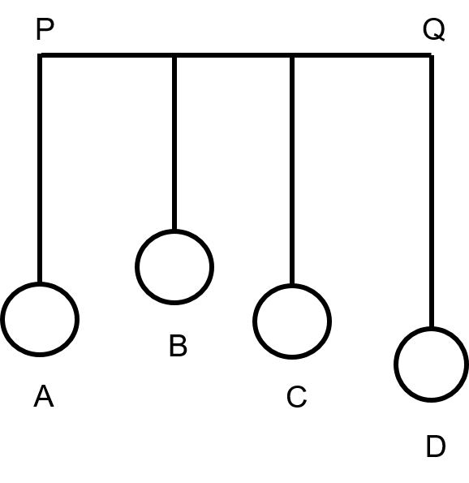

* 1. Name the vibrations taking place in pendulums B and D
  2. What is the state of pendulum C
  3. State the reason for the type of vibrations in pendulum B and C **[5 marks]**

**2014**

1. (a) What are mechanical waves

(b) Name one property of waves that do not change when the wave passes from one medium to another [**2M]**

1. The adjacent diagram shows three different modes of vibrations P, Q and R of the same string.

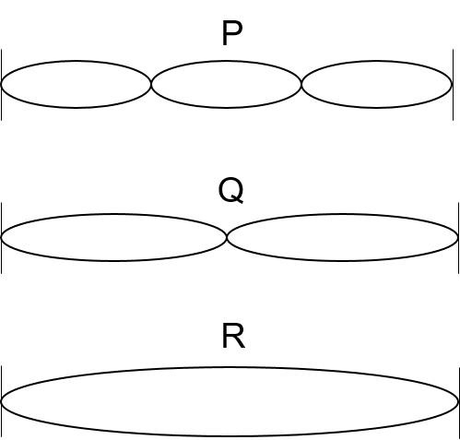

* 1. Which vibration will produce a louder sound and why?
  2. The sound of which string will have maximum shrillness?
  3. State the ratio of wavelengths of P and R **[4M]**

1. A type of electromagnetic wave has wavelength 50 Å
2. Name the wave.
3. What is the speed of the wave in vacuum?
4. State one use of this type of wave. **[3M]**
5. (i) State one important property of waves used for echo depth sounding.

(ii) A radar sends a signal to an aircraft at a distance of 30 km away and receives it back after 2 x 10-4 second. What is the speed of the signal? **[4M]**

**2013**

1. A bucket kept under a running tap is getting filled with water. A person sitting at a distance is able to get an idea when the bucket is about to be filled. **[2 marks]**
   1. What change take place in the sound to give this idea?
   2. What causes the change in the sound?
2. A sound made on the surface of a lake takes 3 s to reach a boatman. How much time will it take to reach a diver inside the water at the same depth? Velocity of sound in air and water is 300 ms-1 and 1450 ms-1 respectively **[2 marks]**
3. Answer the following questions **[3 marks]**
   1. What is the principle on which SONAR is based?
   2. An observer stands at a certain distance away from a cliff and produces a loud sound. He hears the echo of the sound after 1.8 s. Calculate the distance between the cliff and the observer if the velocity of sound in air is 340 m/s.
4. A vibrating tuning fork is placed over the mouth of a burette filled with water. The tap of the burette is opened and the water level gradually starts falling. It is found that the sound from the tuning fork becomes very loud for a particular length of the water column.
   1. Name the phenomenon taking place when this happens.
   2. Why does the sound become very loud for this length of water column?  **[3 marks]**
5. Answer the following questions **[4 marks]**
   1. What is meant by the terms amplitude and frequency of a wave
   2. Explain why stringed musical instruments, like the guitar, are provided with a hollow box

**2012**

1. Which characteristic of sound will change if there is a change in **[2 marks]**
   1. Its amplitude
   2. Its wave form
2. Answer the following questions **[2 marks]**
   1. Name one factor which affects the frequency of sound emitted due to vibrations in an air column
   2. Name the unit used for measuring the sound level
3. (a) What is meant by resonance?

(b) State two ways in which resonance differs from forced vibrations **[3 marks]**

1. (a) A man standing between two cliffs produces a sound and hears two successive echoes at intervals of 3s and 4s respectively. Calculate the distance between the two cliffs. The speed of sound in air is 330 m/s

(b) why will an echo not be heard when the distance between the source of sound and the reflecting surface is 10 m **[3 marks]**

1. The diagram below shows the displacement-time graph for a vibrating body.

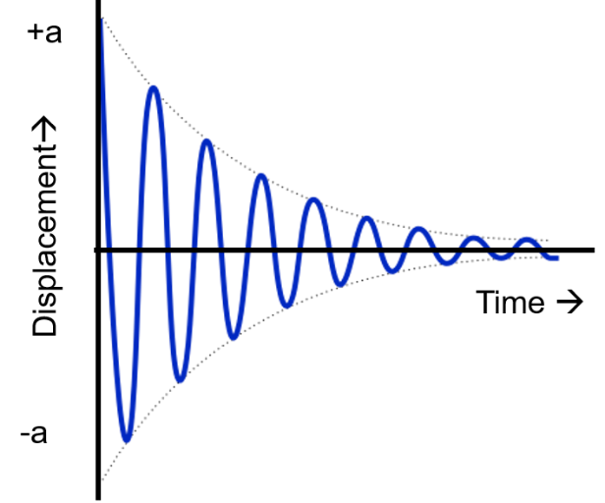

* 1. Name the type of vibrations produced by the vibrating body
  2. Give one example of a body producing such vibrations
  3. Why is the amplitude of the wave gradually decreasing?
  4. What will happen to the vibrations of the body after some time **[4 marks]**

**2011**

1. When acoustic resonance takes place a loud sound is heard. Why does this happen? Explain **[2 marks]**
2. (a) Three musical instruments give out notes at the frequencies listed below. Flute: 400 Hz, Guitar : 200 Hz, Trumpet : 500 Hz. Which one of these has the highest pitch?

(b) with which one of the following frequencies does a tuning fork of 256 Hz resonate? 288Hz, 314 Hz, 333 Hz, 512 Hz **[2 marks]**

1. (a) Name the type of waves which are used for sound ranging

(b) Why are the waves mentioned in (a) above, not audible to us?

(c) Give one use of sound ranging  **[3 marks]**

1. A man standing 25 m away from a wall produces a sound and receives the reflected sound
   1. Calculate the time after which he receives the reflected sound if the speed of sound in air is 350 m/s
   2. Will the man be able to hear a distinct echo? Give a reason for your answer **[3 marks]**

**2010**

1. Name the subjective property of sound related to its frequency **[1 mark]**
2. State two differences between light waves and sound waves **[2 marks]**
3. Two waves of the same pitch have their amplitudes in the ratio 2:3 **[2 marks]**
   1. What will the ratio of their loudness
   2. What will be the ratio of their frequencies
4. (a) A man stands at a distance of 68 m from a cliff and fires a gun. After what time interval will he hear the echo, if the speed of sound in air is 340 m/s

(b) If the man had been standing at a distance of 12 m from the cliff would he have heard a clear echo? **[3 marks]**

**2009**

1. An ultrasonic wave is sent from a ship towards the bottom of the sea. It is found that the time interval between the sending and the receiving of the wave is 1.5 s. The depth of the sea [if the velocity of sound in sea water is 1400 m/s] is **[2 marks]**
2. A stringed musical instrument, such as sitar, is provided with a number of wires of different thicknesses. Explain the reason for this. **[2 marks]**
3. What is meant by noise pollution. Write the name of one source of sound that causes noise pollution **[2 marks]**
4. (a) what is the principle on which sonar is based?

(b) calculate the minimum distance at which a person should in front of reflecting surface so that he can hear a distinct echo. (take speed of sound in air =350 m/s) **[3 marks]**

1. (a) Name the characteristic of sound which enables a person to differentiate between two sounds with equal loudness but having different frequencies

(b) Define the characteristic named by you in (a)

(c) Name the characteristic of sound which enables a person to differentiate between two sounds of the same loudness and frequency but produced by different instruments **[3 marks]**

1. (a) A person is tuning his radio set to a particular station. What is the person trying to do to tune it?.

(b) Name the phenomenon involved, in tuning the radio set

(c) Define the phenomenon named by you in part (b) **[4 marks]**

**2008**

1. (a) What Is meant by an echo? Mention one Important condition that is necessary for an echo to be heard distinctly.

(b) Mention one Important use of echo. **[3 marks]**

1. (a) Sometimes when a vehicle is driven at a particular speed, a rattling sound is heard. Explain briefly, why this happens and give the name of the phenomenon taking place.

(b) Suggest one way by which the rattling sound could be stopped. **[4 marks]**

1. A radar sends a signal to an aeroplane at a distance 45 km away with a speed of 3 x 108 m/s. After how long is the signal received back from the aeroplane **[2 marks]**

**2007**

1. Define the terms amplitude and frequency as applied to sound waves **[2 marks]**
2. A man standing in front of a vertical cliff fires a gun. He hears the echo after 3s. on moving closer to the cliff by 82.5 m, he fires again. This time, he hears the echo after 2.5 s. calculate
   1. The distance of the cliff from the initial position of the man
   2. The velocity of the sound **[3 marks]**

**2006**

1. Explain why musical instruments like the guitar are provide with a hollow box **[2 marks]**
2. When a tuning fork stuck by a rubber pad, is held over a length of air column in a tube, it produces a loud sound for a fixed length of the air column
   1. Name the above phenomenon
   2. How does the frequency of the sound compare with that of the tuning fork?
   3. State the unit for measuring loudness **[3 marks]**

**2005**

1. Mention two properties of wave: one property which varies and the other which remains constant when the wave passes from one medium to another **[2 marks]**
2. A radar is able to detect the reflected waves from an enemy aeroplane after time interval of 0.02 milliseconds. If the velocity of the waves is 3x108 m/s. Calculate the distance of the plane from the radar **[3 marks]**

**2004**

1. What is Sonar? State the principle on which it is based.**[2 marks]**
2. Differentiate between resonance and forced vibrations **[2 marks]**
3. The wavelength of waves produced on the surface of water is 20 cm. If the wave velocity is 24 m/s, calculate
   1. The number of waves produced in one second and
   2. The time required to produce one wave. **[4 marks]**

**2003**

1. The ratio of the amplitudes of two waves is 4 : 9. What is the ratio of their intensities? **[1 mark]**
2. A pendulum has a frequency of 5 vibrations per second. An observer starts the pendulum and fires a gun simultaneously. He hears the echo from a cliff after 8 vibrations of the pendulum. If the velocity of sound in air is 340 m/s, what is the distance between the cliff and the observer? **[4 marks]**
3. (i) Sound made in front of a tall building 18 m away, is repeated. Name the phenomenon and briefly explain it.

(ii) A tuning fork, held over an air column of a given length, produces a distinct audible sound. What do you call this phenomenon? How does it occur? **[5 marks]**

**2002**

1. An observer stands at a distance of 850 m from a cliff and fires a gun. After what time-gap will he hear the echo, if sound travels at a speed of 350 m/s in air? **[2 marks]**
2. A vibrating tuning fork is placed over the mouth of a burette filled with water. The tap is opened and the water level gradually falls. It is observed that the sound becomes the loudest for a particular length of air column.
   1. What is the name of the phenomenon taking place when this happens? **[1 mark]**
   2. Why does the sound become the loudest? **[1 mark]**
   3. What is the name of the phenomenon taking place when sound is produced for another length of air column and is not the loudest? **[2 marks]**
3. What change, if any, would you expect in the characteristics of a musical sound when we increase:
   1. Its frequency,
   2. Its amplitude. **[2 marks]**

**2001**

1. (a) Give one example each. of natural vibration, forced vibration and resonance.

(b) Mention one practical use of echoes. **[4 marks]**

1. (a) State three characteristics of a musical sound.

(b) How does the musical sound differ from noise? **[4 marks]**

1. (a) How does a stretched string on being set into vibration, produce the audible sound?

(b) Will the sound be audible if the string is set into vibration on the surface of the

moon? Give reason for your answer. **[4 marks]**

1. Radio waves of speed 3 × 108 m/s are reflected of the moon and received back on earth, the time elapsed between the sending of the signal and receiving it back at

the earth surface is 2.5 seconds, What is the distance of the moon from the earth? **[4 marks]**

**2000**

1. (a) Two friends were playing on their identical guitars whose strings were adjusted to give notes of the same pitch. Will the quality of the two notes be the same? Give a reason for your answer.

(b) Give the relation wavelength, time-period and wave-velocity of a wave motion **[4 marks]**

1. A sound wave of wavelength 0.332 m has a time period of 10-3 s. If the time period is decreased to 10-4 s; calculate the wavelength and frequency of the new wave. **[3 marks]**
2. (a) Define the terms: Amplitude and frequency for sound waves.

(b) Name the subjective property of sound related to its frequency and of light related to its wavelength **[3 marks]**

**1999**

1. (a) Under what condition does the resonance occur? **[1 marks]**

(b) Why is a loud sound heard at acoustic resonance? **[1 marks]**

1. (a) A certain sound has a frequency of 256 hertz and a wavelength of 1 .3 m. Calculate the speed with which these sound travels. **[2 marks]**

(b) What difference would be felt by a listener between this sound and another sound travelling at the same speed but of wavelength 2.6 m? **[1 marks]**

**1997**

1. (a) State any two characteristics of a wave motion.

(b) What is the relation between frequency, wavelength and speed of a wave?

(c) A longitudinal wave of wavelength 1 cm travels in air with a speed of 330 m/s. Calculate the frequency of the wave. Can this wave be heard by a normal human being? **[6 marks]**

1. Two waves A and B have wavelengths 0·01 Å and 9000 Å respectively. **[4 marks]**
   1. Name the two waves.
   2. Are the speeds of these two waves equal when they travel in vacuum?
   3. If the amplitude of a wave is doubled what will be the effect on its loudness?

**1996**

1. (a) Define the phenomenon of resonance. **[2 marks]**

(b) A stretched wire 0.5 m long is made to vibrate in two different modes as shown in diagram (A) and (B) given below:

1. If the wavelength of the wave produced in mode (A) is 1 m, what is the wavelength of the wave produced in mode (B) of the following diagram?
2. In which case is the note produced louder? Give a reason for your answer.
3. In which case is the pitch of the note produced is higher? Give a reason for your answer. **[4 marks]**

